 | Title : Project Registration & Progress Review |  | FF No. 180
Department: AI&DS |  | Academic Year: 2026-2027
Semester : TY-1 |  | Group No. : 1
Project Title: Magic Mirror: Speech to Live Visualization.
Project Area: Artificial Intelligence, Computer Vision, Generative AI, Augmented Reality
Group Members Details:

Sr. No. | Class & Div. | Roll No. | G.R.No. | Name of Student | Contact No. | Email ID
1 | AIDS-F | 44 | 12414003 | Umar Shaikh | 8530908294 | umar.shaikh24@vit.edu
2 | AIDS-F | 23 | 12413731 | Siddhesh Songare | 7757927406 | siddhesh.songare24@vit.edu
3 | AIDS-F | 25 | 12414050 | Maithili Supekar | 96999 44915 | maithili.supekar24@vit.edu
4 | AIDS-F | 58 | 12413270 | Yash Patil | 7709184941 | dipak.yash24@vit.edu
5 | AIDS-F | 10 | 12414446 | Shreeya Shinde | 95271 29155 | shreeya.shinde241@vit.edu

Name of Internal Guide: Prof. Neha Prabhakar Rajas
Contact No. & Email ID: +91 7499 852 984, neha.rajas@vit.edu

Project approved / Not approved

Guide Project Coordinator Head of Department

T
FF No 180

Project Synopsis

Introduction -
Magic Mirror is a multimodal AI system designed to automatically turn a speaker's natural explanation into live visualisations. Unlike voice-controlled systems, the speaker does not give explicit commands. The system listens to what they are explaining, understands the context, identifies concepts that could benefit from visualisation, and generates or retrieves an appropriate visual.
For example, when a lecturer says, “Imagine an electron orbiting around the nucleus,” the system can understand the concept and display an animated atomic visualisation. Similarly, when a presenter says, “Think of a dog sitting here on my hand,” computer vision can detect the hand and anchor the generated dog to it in the live camera feed.

Objectives -
- To develop a system capable of understanding natural speech and its contextual meaning in real time.
- To identify concepts, actions, and spatial references within a speaker’s explanation that can benefit from visualisation.
- To generate or retrieve appropriate visual representations based on the inferred context.
- To detect and track gestures, hands, and spatial locations for accurate placement of generated visuals.
- To integrate the generated visuals into the live camera feed using real-time augmented reality techniques.

Proposed Technology
- Speech-to-Text
- Multimodal LLM / Contextual Reasoning
- Computer Vision and Hand Tracking
- Generative AI
- Spatial Tracking
- WebGL / GPU-based AR Compositing
- Applications using online education and lectures
- Live presentations
- Content creation and streaming
- Product demonstrations
- Remote training

Methodology -
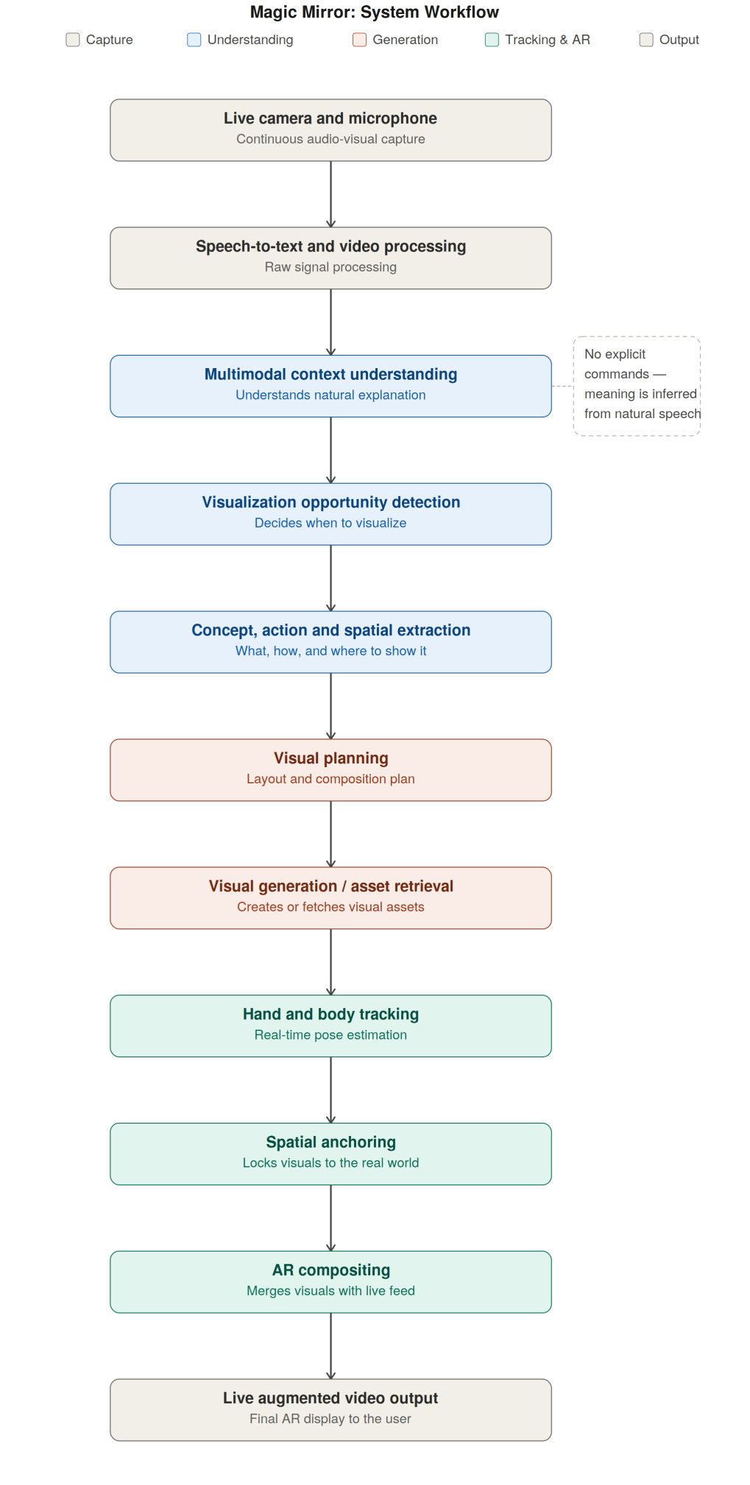
Fig.01 - Magic Mirror Flowchart

Key Idea
Magic Mirror allows speakers to explain ideas naturally while the system understands the context of what they are saying. It automatically identifies what could be visualised, generates or retrieves the appropriate visual, and brings the explanation to life in the live camera feed.

FF No 180

Group No.
Activity | Review Schedule | Progress Review Report submitted | Signature of Guide
Review 1 | Mid Sem. Semester | Yes / No
Review 2 | End of Semester | Yes / No

Format of Progress Review Report:

Review No.: 1 Group No.: Date:

Progress Review Report

Signature of Guide:

Review No.: 2 Group No.: Date:

Progress Review Report

Signature of Guide:

